**DAILY ONLINE ACTIVITIES SUMMARY**

|  |  |  |  |  |  |  |  |  |
| --- | --- | --- | --- | --- | --- | --- | --- | --- |
| **Date:** | **19/05/2020** | | | | | **Name:** | **Katira Krishna J** | |
| **Sem & Sec** | **8th A** | | | | | **USN:** | **4AL16CS045** | |
| **Online Test Summary** | | | | | | | | |
| **Subject** | | **BDA** | | | | | | |
| **Max. Marks** | | **30** | | **Score** | | | **22** | |
| **Certification Course Summary** | | | | | | | | |
| **Course** | **Big Data 101** | | | | | | | |
| **Certificate Provider** | | | **Cognitiveclass.ai** | | **Duration** | | | **35 mins** |
| **Coding Challenges** | | | | | | | | |
| **Problem Statement: 1.To check if the 2 strings are anagrams 2. Java program** | | | | | | | | |
| **Status: Completed** | | | | | | | | |
| **Uploaded the report in Github** | | | | | **yes** | | | |
| **If yes Repository name** | | | | | **Daily_CODING_CHALLENGES** | | | |
| **Uploaded the report in slack** | | | | | **yes** | | | |

Online Test Details: (Attach the snapshot and briefly write the report for the same)

Online Test Details:

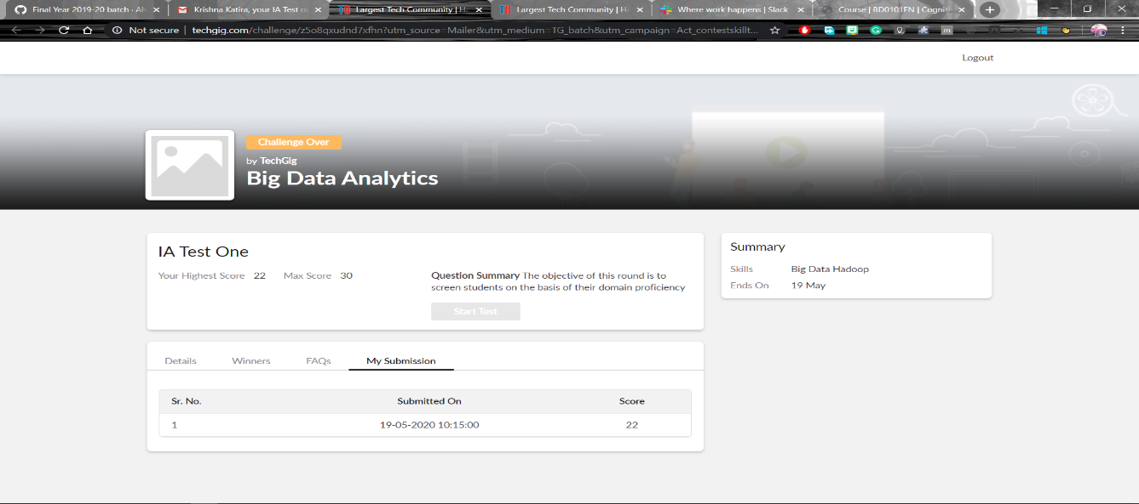

Certification Course Details:

Beyond the hype of the term 'Big Data', this course shows how Big Data is being adopted in different industries. When you complete this course and earn a badge, you will have a greater understanding of what Big Data is, how it can impact different businesses and, some of the technology used to manage Big Data.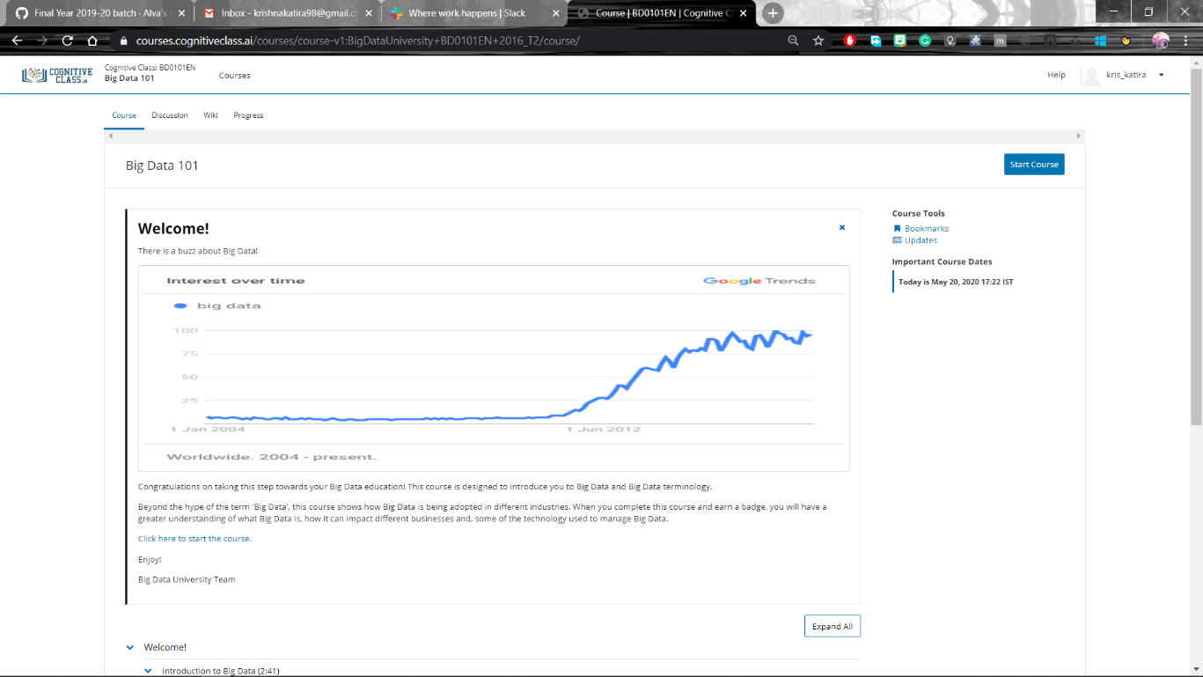

Coding Challenges Details:

**program1:**

package shortestpalindromeexample.java;  
import java.util.Scanner;

public class ShortestPalindromeDemo {

public static String shortestPalindrome(String str) {

int x=0;  
int y=str.length()-1;

while(y>=0){  
if(str.charAt(x)==str.charAt(y)){  
x++;  
}  
y--;  
}

if(x==str.length())  
return str;

String suffix = str.substring(x);  
String prefix = new StringBuilder(suffix).reverse().toString();  
String mid = shortestPalindrome(str.substring(0, x));

return prefix+mid+suffix;  
}

public static void main(String[] args) {

Scanner in = new Scanner(System.in);

System.out.println("Enter a String to find out shortest palindrome");

String str=in.nextLine();

System.out.println("Shortest palindrome of "+str+" is "+shortestPalindrome(str));

}

**program 2**

import java.util.Stack;

class Node {  
int data;  
Node next;

Node(int i)

{

this.data = i;

this.next = null;

}

};

class Main  
{  
public static booleanisPalindrome(Node head)  
{  
// construct an empty stack  
Stack s = new Stack<>();  
Node node = head;  
while (node != null) {  
s.push(node.data);  
node = node.next;  
}

node = head;

while (node != null)

{

int top = s.pop();

if (top != node.data) {

return false;

}

node = node.next;

}

return true;

}

public static void main(String[] args)

{

Node head = new Node(1);

head.next = new Node(2);

head.next.next = new Node(3);

head.next.next.next = new Node(2);

head.next.next.next.next = new Node(1);

if (isPalindrome(head)) {

System.out.print("Palindrome.");

} else {

System.out.print("Not palindrome.");

}

}

}